Healthwatch Swindon Volunteer Role Description

 |  | Young Healthwatch Swindon Volunteer
Purpose of the role: |  | To help Healthwatch Swindon ensure that it listens, and learns from the voice and experience of young people.
What you will be doing: | 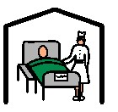 | You will be part of Young Healthwatch Swindon, a young people’s group that will help Healthwatch Swindon by:  - Helping to influence our work that aims to make health and social care services better for children and young people.  - Being involved in projects to gather views about children and young people’s experiences of health and social care services.  - Help advise Healthwatch Swindon and other services how they can be more ‘child and young people friendly’  - Acting as a role model for young people’s involvement by helping us talk to and listen to other children and young people
Where: |  | Meetings will be held in a town centre venue.  If meetings aren’t for you, you can contribute virtually.
When: | 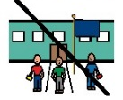 | Young Healthwatch Swindon will meet at least once every six weeks. Meetings will be held outside school/college hours eg. Evenings, weekends or school holidays. There will be other opportunities to volunteer in other activities between meetings.
Time Commitment: |  | Ongoing. Flexible time commitment to be agreed: minimum 2 hours/month
What you need to be able to do: | 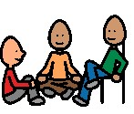 | - Be aged 16-25 and live or study in Swindon.  - Be patient and a good listener  - Able to challenge and disagree without being confrontational  - Be able to work as part of a team with other young people and/or Healthwatch Swindon workers  - Agree to the Healthwatch Swindon Code of Conduct.  - Able to represent the views and experiences of others, not just your own.
Experience and knowledge: | 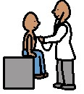 | - Experience of having accepted responsibility and seeing things through  - Interested in people  - Personal experience of accessing different health and social care services would be useful
Attitudes and Values: |  | - Committed to children and young people having a say and being heard.  - Be non-judgemental  - Respect for those from a different background
What’s in it for you? | 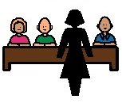  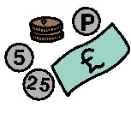 | - Support and training from Healthwatch Swindon will be available to help you with this role.  - We’ll provide you a reference after 30 hours volunteering with us, and certificates for any training you do with us.  - It won’t cost you anything to volunteer, with us – we’ll pay your travel costs, and there will be refreshments/food at most of our meetings!

The Picture Communication Symbols ©1981–2011 by Mayer-Johnson LLC. All Rights Reserved Worldwide. Used with permission. Boardmaker® is a trademark of Mayer-Johnson LLC.

